CONFIDENTIAL FILE NOTE: -Sharing and Seeking Information

Child’s Name | DOB | Provision

Liaised with: |  | Date |  | Time
Contacted |  | Tel No.
Email details |  | Email details
(please specify including full name, job title or relationship to child)
Details/Key Points or concerns to discussed:

Agreed actions (include person responsible and timescales):
Evidence of Follow-up action taken by DSL:
(include progress against agreed actions, follow-up with other professionals, parents and child including the date)

Further Action Agreed - Identify action:
e.g. Early Years Provisions/School to instigate a Family Support Process, assessment by Children’s Services

Any other details

Full name: Role:

DSL Signature:

Date:

Your name/logo here eg; INSPIRE to Learn LTD

Recording Form for Safeguarding Concerns
to be completed in black printed ink
Staff, volunteers and regular visitors are required to complete this form and pass it to
[ENTER NAME OF DSL]
if they have a safeguarding or protection concern about a child or vulnerable individual
Name and Role of person completing this information | Date and time

Full name of child or individual | Date of Birth | Provision | Your name and role

Nature of concern/disclosure
Date Time
Please include where you were when the child or other individual made a disclosure, what was shared, what you saw, identify other individuals present, what did the child say or do and how the response.

Details of any other individual present

Was there an injury? Yes / No Did you see it? Yes / No
Have you completed a body map which evidences where the injury is and its approximate size/colour/etc
Yes / No

Please identify or attaché it or other relevant information to this form

Provide details-
Has there been any previous concern?

Was this documented? ( Please identify and attaché)

Have there been any previous incidents?

Has the parent/carer other individual completed an accident or incident form or shared any relevant information which needs to be documented

Has the parent/carer been informed consider ‘ is it safe to do so at this stage’ seek advice if unsure
If not document why and responses if informed

Who and where are you seeking any additional guidance or advice/ information from?

Service: Position:

Name:

Document discussion

Who are you passing this information to and when?

Name:

Position:

Your signature:

Time form completed: Date:
Follow: Government Information Sharing Guide 2015 - & Golden rules of information sharing

Recording Form for Safeguarding Concerns
to be completed in black printed ink

Date Time form received by Named DSL:

Action and response taken by DSL:

Sought advice or Referred to:

Attendance
Improvement
Officer Police School Nurse Children’s HV/Other Guidance LSCB Care Services Adviser

Date: Time:

Parents informed? Yes / No (If No, state reason)

Feedback given to

Parent Child Person who recorded disclosure Other identify whom

Further Action Agreed:
e.g. Early Years Provision /School to instigate a Family Support Process, assessment by Children’s Services

Identify the action agreed and time scales

Full name:
DSL Signature:
Date:

□

SAFEGAURDING - CHILD PROTECTION RECORD

Person completing this form:
(Black printed ink)

Date concern file started:
 | Current |  | Changed to | Changed to
Status:
CP, CIN, CAF, Cause for Concern
Name of child:

Any other names by which the child is known/has been known:
Date of birth: |  |  | ----- | -----
Address:

Preferred spoken Language of child and parent/main carer
Other family members:
(include full name, relationship, if under 18 include age and provision/school where known)
Are any other child protection files held in the provision /school relating to another child closely connected to this child? | Yes (circle)  (please identify which other child) |  |  | No (circle)
Name and contact number of key workers:
Include Children’s Services Social Care and any other relevant professionals

Name and contact number of GP and Health visitor if known:

[ENTER NAME] Provision /School is committed to safeguarding and promoting the welfare of children and young people and expects all staff and volunteers to share this commitment.

Body Map Guidance to Safeguard and Protect Children

Body Maps should be used to document and illustrate visible signs
of harm and physical injuries.

Always use a black pen (never a pencil) and do not use correction fluid or any other eraser.

Do not remove clothing for the purpose of the examination unless the injury site is freely available because of treatment.
*At no time should an individual teacher/member of staff or school take photographic evidence of any injuries or marks to a child’s person, the body map below should be used.
Any concerns should be reported and recorded without delay to the appropriate safeguarding services, e.g. Social Care direct or child’s social worker if already an open case to social care.

When you notice an injury to a child, try to record the following information in respect of each mark identified e.g. red areas, swelling, bruising, cuts, lacerations and wounds, scalds and burns:

- Exact site of injury on the body, e.g. upper outer arm/left cheek.
- Size of injury - in appropriate centimetres or inches.- relate to an item eg 10/50pence coins
- Approximate shape of injury, e.g. round/square or straight line.
- Colour of injury - if more than one colour, say so.
- Is the skin broken?
- Is there any swelling at the site of the injury, or elsewhere?
- Is there a scab/any blistering/any bleeding?
- Is the injury clean or is there grit/fluff etc.?
- Is mobility restricted as a result of the injury?
- Does the site of the injury feel hot?
- Does the child feel hot?
- Does the child feel pain?
- Has the child’s body shape changed/are they holding themselves differently?
- Has there been any treatment sought or provided if so where from and whom?

Document the discussions include any advice provided or sought

Add any further comments as required.

Importantly the date and time of the recording must be stated as well as the name and designation of the person making the record.

Ensure First Aid is provided where required and record

A copy of the body map should be kept on the child’s concern/confidential file.

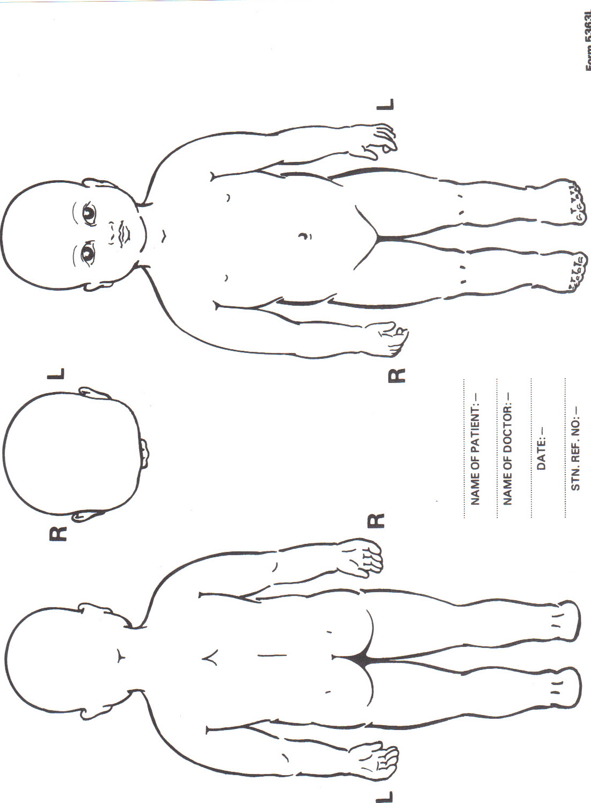
LSCB GUIDANCE FOR COMPLETING
Referrals and Forms

Referral to Children’s Social Care 2017

The referral forms are structured to promote safer working practice and share key information:

- Empower and enable all partners to work together to provide the right service at the right time for the right duration, including partners continued engagement in plans to safeguard and promote the child’s welfare, regardless of Children’s social care involvement

- Supporting partners need to recognise the family’s strengths as well as clearly articulate the concerns and what they want to happen next using the ‘Think Family Approach’

- Focus on gaining the consent of the family so that we remember to work with the family to address the concerns when safe to do so

All referrals should be made with reference to the LSCB Threshold Guide/Continuum of Needs downloaded from the LSCB website

We need to encourage all people who are concerned about a child to seek support and guidance from their line managers and/or designated safeguarding leads, prior to making a referral.

However, if a child is at risk of immediate harm, do not delay to submit a referral to ensure that the child is protected at the earliest opportunity.

The LSCB Threshold Guide provides information and has a new emphasis on having conversations about our concerns to help us to work together to:

- focus on the needs of the child
- manage any uncertainty
- support informed decision making
- improve the way we work together

We need to also recognise that these conversations may be difficult. Learning from Serious Case Reviews, tells us that professional challenges are key to effective decision making, planning and ultimately achieving the best outcomes for the children we are worried and concerned about.

We urge all partners to have the confidence to respectfully challenge each other and to use the Resolving Professional Disagreement policy where required if agreements are not made.

EXISITING CASES - PLEASE NOTE: If you are submitting information towards a case that is already open to Children’s Services - The information should be passed to the social worker managing the case and it is their responsibility to advise the person concerned on next steps.

In these cases, please ensure that you have the social worker’s contact details or contact the social care team in your locality area if you do not get a response and outline the key aspects of your concerns include and specify time of return contact to avoid drifting along and delays

Please ensure you have their up to date names and email details including contact numbers to forward any concerns, information or queries these need to be sent and stored securely

Safer and Efficient Working Practice - Completing a referral:

- Ensure that any paper documentation is clearly written in black printed ink and the referrer’s contact details are completed in full.

- Get the parents’/carers’ consent when safe to do so, If unsure seek advice first and document discussion details.

- If you do not have this you need to be really clear why you are referring without consent, i.e you believe the child to be at risk of significant harm which will be escalated if raised with the parents/carers prior to referral.

- Provide as much detail as possible about the child/their siblings, the family and the people in their safeguarding network to establish potential risks and protective factors.

- Please include details about:

- The child/family’s nationality and any additional needs/languages spoken: is a translator required?
- Information relating to values, culture, beliefs and spirituality
- Any disability and/or other caring arrangements
- Any medical conditions or concerns

- Identify any agencies you know are currently working with the child/family.

- With the referral information, be as clear as possible about:

- What you are worried about: from the child’s perspective what impact are the concerns you are raising having on them?
- What strengths/protective factors are in place: what works well for the child/family?
- What you want to happen next: who is best placed to provide the right service to address the concerns raised and ensure the child’s safety?
- What outcomes you would like: what does safe look like for this child?

- Make reference to the Threshold Guide and link any concerns to the levels,
Use the prompt questions in the Guide to support your concerns and to document or seek advice from the children’s social care team

- Clarify your role in the child/family’s life and how/if you will continue to be involved in safeguarding plans.

- If any existing plan/assessment is in place (Family Support Plan, Care Plans or previous social care assessment) please attach it to the referral and inform the SW and team involved see notes on existing cases

If you have a concern regarding a child or young person and would like to discuss it further you can also contact the social care services number for a consultation.

After Referrals- Feedback Document - to be sent back to original Referrer

Name and address of person that form should be sent back to
To be completed by referrer:

Date referral sent:

Date referral received:
Person managing the referral and their contact details:

 |  | Yes  ✓ | No  ✓
Family seen as a result of this referral
Child seen as a result of this referral
Family have been advised of outcome of referral
Background information has been collated
The family have been contacted by Social care Services and an initial assessment will be completed (only complete if referral to Assessment Team add details)

Outcome:
Services offered to family – if yes, please specify
Further referral made – if yes, please specify and attach relevant information
No further action
Strategy discussion under Section 47 –
(only complete if referral to Assessment Team and relevant details)

This form to be returned within 7 working days to original referral

Local Safeguarding Children Boards (LSCB)

Visit the LSCB website for your Local Authority

Helplines and websites
- Childline: 08001111
- Samaritans: 08457 909090
- NSPCC helpline freephone: 0808 800 5000
- Sexual abuse helpline freephone: 0808 1000 900
- Domestic Violence Helpline: 01226 249800
- Women's Aid Helpline: 0808 2000 247
www.refuge.org.uk/get-help-now/what-is-domestic-violence
- Thinkuknow www.thinkuknow.co.uk
- Childnet www.childnet.com/resources
- Kidscape www.kidscape.org.uk

- Pace -Parents against Exploitation on 0113 240 5226
http://paceuk.info/about-pace/contact-us/

